Fraction War

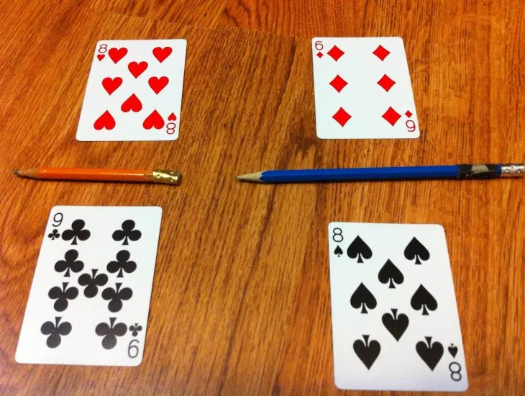

**Materials:**

* Deck of Cards
* Pencil
* Paper
* Pencils

Students take turns playing “war” using a deck of cards and a pencil to act as the fraction line. The pair of students must then decide who has the larger fraction based on the four cards played. The winner gets to keep all the cards. Player with most cards at end wins.  
**Goal**: to develop quick comparison of fraction values

**Rules:**

* Shuffle and deal the cards.
* Each player puts their cards faced down in a pile.
* Both players turn over TWO cards at the same time (one above the pencil and one below).
* The player whose cards has the larger fraction wins all four cards.
* Players may use the paper to figure equivalent fractions or use the Tip Sheet.
* If players turn over equivalent fractions, then there is a fraction war.
* Each player places 2 new cards face down and the 3rd & 4th card face up (one above the pencil and one below).
* Who ever has the higher fraction wins all the cards.
* The game can continue until one player has all the cards or for a given amount of time.

**Fraction War Tips and Tricks**

* If two fractions have a common denominator, the fraction with the larger numerator is the larger fraction. Ex: 3/5 > 2/5
* If two fractions have a common numerator, the fraction with the smaller denominator is larger. Ex: 1/4 > 1/8